**SUNNY TEST CASES**

**IT_CASE 1 : INSERT**

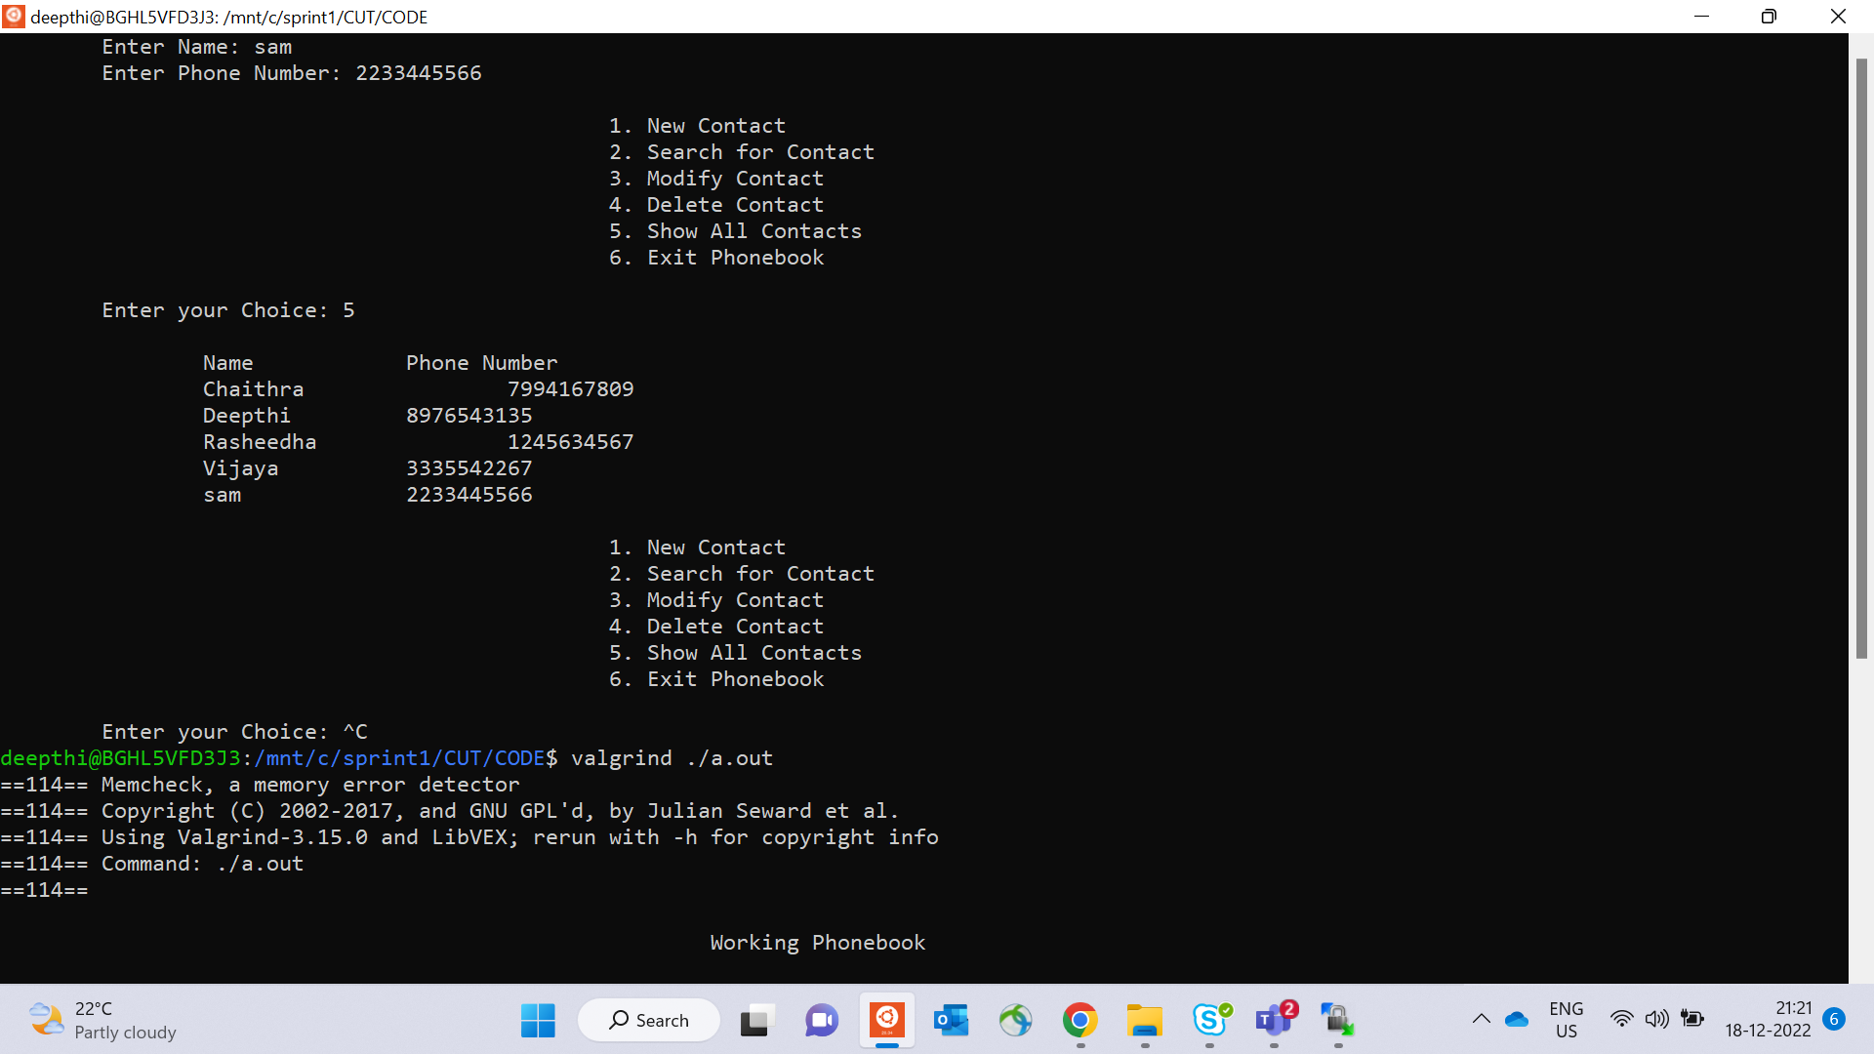

**IT_CASE 2 : SEARCHBYNAME**

**IT_CASE 3 :SEARCHBYNUMBER**

**IT_CASE 4 : MODIFYBYNAME**

**IT_CASE 5 : MODIFYBYNUMBER**

**IT_CASE 6 : DELETE**

**IT_CASE 7 :DISPLAY**

**RAINY TEST CASES**

**IT_CASE 1:**

